1. **Types of Properties**

## **DDL:**

## CREATE TABLE PropertyType (

## TypeID VARCHAR(10) NOT NULL,

## TypeName VARCHAR(50) NOT NULL,

## CONSTRAINT PropertyType_PK PRIMARY KEY(TypeID) );

## **Query Screenshot:**

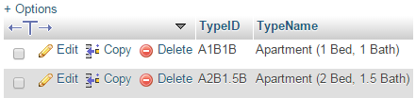

1. **Property**

## **DDL:**

## CREATE TABLE Property(

## PropertyID VARCHAR(20) NOT NULL,

## PropertyName VARCHAR(60) NOT NULL,

## Address VARCHAR(50),

## ZipCode VARCHAR(10) NOT NULL,

## PhoneNo VARCHAR(15),

## Rating DECIMAL(5,2),

## CONSTRAINT Property_PK PRIMARY KEY(PropertyID) );

## **Query Screenshot:**

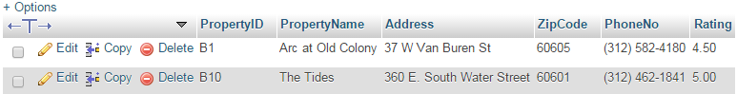

1. **Apartment**

## **DDL:**

## CREATE TABLE APARTMENT(

## ApartmentID VARCHAR(20) NOT NULL,

## PropertyID VARCHAR(20) NOT NULL,

## Price DECIMAL(6,2) NOT NULL,

## LeasePeriod VARCHAR(10),

## TypeID VARCHAR(10) NOT NULL,

## CONSTRAINT Apartment_PK PRIMARY KEY(ApartmentID ),

## CONSTRAINT Apartment_FK1 FOREIGN KEY(TypeID) REFERENCES PropertyType(TypeID),

## CONSTRAINT Apartment_FK2 FOREIGN KEY(PropertyID) REFERENCES Property(PropertyID) on DELETE CASCADE );

## **Query Screenshot:**

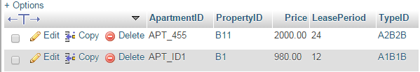

1. **Agent Details**

## **DDL:**

## CREATE TABLE AgentDetails(

## AgentID NUMERIC(10,0) NOT NULL,

## AgentFirstName VARCHAR(15) NOT NULL,

## AgentLastName VARCHAR(15),

## AgentRating INT(5) NOT NULL,

## PhoneNo VARCHAR(15) NOT NULL,

## CONSTRAINT AgentDetails_PK PRIMARY KEY(AgentID) );

## **Query Screenshot:**

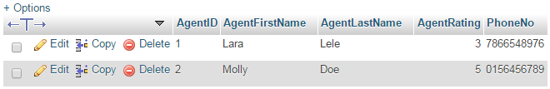

1. **Agent Area**

## **DDL:**

## CREATE TABLE AgentArea(

## AgentID NUMERIC(10,0) NOT NULL,

## ZipCode VARCHAR(10) NOT NULL,

## CONSTRAINT AgentArea_PK PRIMARY KEY (AgentID, ZipCode),

## CONSTRAINT AgentArea_FK2 FOREIGN KEY(AgentID) REFERENCES AgentDetails(AgentID) );

## **Query Screenshot:**

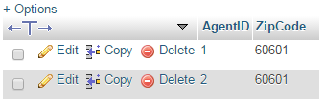

1. **User details**

## **DDL:**

## CREATE TABLE UserDetails

## UserName VARCHAR(15) NOT NULL,

## Password VARCHAR(255) NOT NULL,

## email varchar(50),

## telephone varchar(15),

## PostCode varchar(10),

## CONSTRAINT UserDetails_PK PRIMARY KEY(UserName, Password) );

## **Query Screenshot:**



## CREATE TABLE AdminDetails(

## UserName VARCHAR(15) NOT NULL,

## Password VARCHAR(255) NOT NULL);

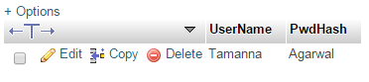

1. **User Interest**

## **DDL:**

## CREATE TABLE userinterest (

## username VARCHAR(15) NOT NULL,

## ApartmentID VARCHAR(20) NOT NULL,

## PropertyName VARCHAR(50) NOT NULL,

## TypeName VARCHAR(50) NOT NULL,

## Price DECIMAL(6,2) NOT NULL,

## LeasePeriod VARCHAR(10),

## Address VARCHAR(50),

## ZipCode VARCHAR(10) NOT NULL,

## Phoneno VARCHAR(15),

## CONSTRAINT userinterest_PK PRIMARY KEY(username,ApartmentID) );

## **Query Screenshot:**

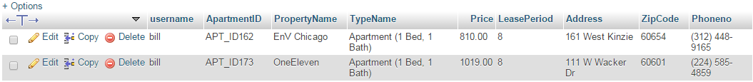

1. **Apartment updates**

## **DDL:**

## create table admin_update_history

## ( id INT AUTO_INCREMENT PRIMARY KEY,

## apt_id varchar(20),

## lease varchar (10),

## price decimal(6,2),

## updated_date DATETIME DEFAULT NULL,

## action varchar(50) DEFAULT NULL );

## **Query Screenshot:**

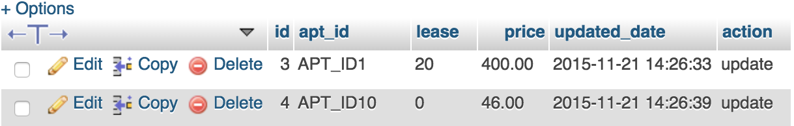

1. **Property updates**

## **DDL:**

## create table admin_update_history_property

## (id INT AUTO_INCREMENT PRIMARY KEY,

## property_id varchar(20),

## property_name varchar (10),

## address varchar (30),

## phone_no varchar(20),

## rating decimal(5,2),

## zipcode varchar(10),

## updated_date DATETIME DEFAULT NULL,

## action varchar(10) DEFAULT NULL );

## **Query Screenshot:**

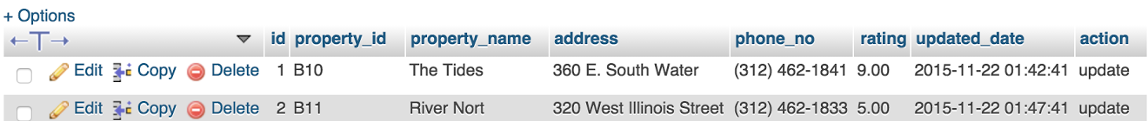

1. **Property Utility**

## **DDL:**

## CREATE TABLE propertyutility(

## PropertyID VARCHAR(20) NOT NULL,

## UtilityID VARCHAR(20) NOT NULL,

## Availability VARCHAR(20),

## Charges DECIMAL(6,2),

## CONSTRAINT propertyutility_PK PRIMARY KEY(PrpertyID,UtilityID),

## CONSTRAINT propertyutility_FK1 FOREIGN KEY(PropertyID) REFERENCES Property(PropertyID) ON DELETE CASCADE,

## CONSTRAINT propertyutility_FK2 FOREIGN KEY(UtilityID) REFERENCES utilitytype(UtilityID) );

## **Query Screenshot:**

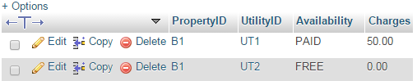

1. **Utility Type**

## **DDL:**

CREATE TABLE utilitytype(

UtilityID VARCHAR(20) NOT NULL,

UtilityDescription VARCHAR(50) NOT NULL,

CONSTRAINT utilitytype_PK PRIMARY kEY(UtilityID) );

## **Query Screenshot:**

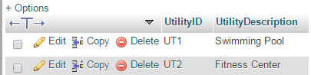

1. **Zipcode information**

## **DDL:**

CREATE TABLE zipcodeindex(

ZipCode VARCHAR(10) NOT NULL,

population INT(11),

VoilentCrime DECIMAL(6,2) NOT NULL,

PropertyCrime DECIMAL(6,2) NOT NULL,

LivabilityIndex DECIMAL(6,2) NOT NULL,

WalkScore DECIMAL(6,2) NOT NULL,

walkScoreRank VARCHAR(100),

CONSTRAINT zipcodeindex_PK PRIMARY KEY(ZipCode) );

## **Query Screenshot:**



1. **Listing**

## **DDL:**

create table listing

( ListingID INT AUTO_INCREMENT PRIMARY KEY,

AgentID decimal(10,0),

 ApartmentID varchar (20),

AddedOn DATETIME DEFAULT GETDATE(),

Status varchar (10),

CONSTRAINT Listing_FK1 FOREIGN KEY(ApartmentID) REFERENCES partment(ApartmentID),

CONSTRAINT Listing_FK2 FOREIGN KEY(AgentID) REFERENCES agentdetails(AgentID) );

## **Query Screenshot:**

